Project Workflow

1. Problem Statement
Datasets used:
- German Credit Dataset
- Australian Credit Dataset
- Credit Score Classification Dataset
- Give Me Some Credit Dataset
This multi-dataset approach enabled cross-domain validation of modeling strategies and improved reliability of conclusions.

2. Data Cleaning
Significant effort was invested in ensuring data quality and consistency:

Text Cleaning
- Standardization of categorical labels (case normalization, trimming, formatting)
- Removal of inconsistencies and redundant representations

Handling Duplicates & Structural Issues
- Certain datasets (e.g., monthly customer records) required group-level consistency checks
- Ensured attributes like income remained consistent across grouped records

Missing Value Imputation
- Group-based imputations (e.g., imputing income within customer groups)
- Statistical imputations depending on feature type and distribution

Outlier Detection & Treatment
- Domain-based thresholding (e.g., debt ratio caps)
- Distribution-aware handling instead of blind removal
- Preservation of high-value outliers where financially meaningful

3. Data Preprocessing
A modular and experimental preprocessing strategy was followed:

Imputation Strategies
- Mean/Median imputation
- KNN Imputation
- Group-wise imputations
- Strategy selection based on feature distribution and dataset behavior

Encoding Techniques
- Ordinal Encoding for binary/categorical ordered features
- One-Hot Encoding for nominal variables
- Careful handling of encoding to avoid dummy variable trap

Feature Scaling
- Logarithmic transformation for skewed variables
- Standard Scaling for model-sensitive algorithms

4. Feature Analysis & Selection
A combination of statistical and diagnostic techniques was used:

Statistical Tests
- Chi-Square Test → for categorical feature relevance
- ANOVA → for numerical feature significance

Exploratory Analysis
- Feature distribution analysis (skewness, kurtosis)
- Correlation matrix to detect relationships

Multicollinearity Analysis
- Variance Inflation Factor (VIF)
- Removal of redundant features to stabilize models
These steps ensured:
- Reduced noise
- Improved interpretability
- Better model generalization

5. Pipeline Engineering
A key strength of the project:
- Built modular preprocessing pipelines
- Pipelines exported and reused across notebooks
- Ensured:
  - Reproducibility
  - Clean workflow separation
  - Consistent transformations across datasets

Custom Transformer Module
- Developed a custom Python module
- Encapsulated:
  - Imputation logic
  - Outlier handling
  - Feature transformations

6. Model Training

Data Splitting Strategy
- Standard Train-Test Split
- Group-based splitting (to prevent leakage in grouped datasets)

Model Development Workflow
- Imported preprocessing pipelines
- Applied feature selection
- Trained baseline models

Algorithms Used
- Logistic Regression (baseline, interpretable)
- Tree-based models (Decision Trees, Random Forest, XGBoost)
- Other classical ML models for benchmarking

7. Hyperparameter Optimization
Multiple tuning strategies were applied:
- Randomized Search CV → efficient exploration
- GridSearchCV → exhaustive fine-tuning
- Optuna → advanced optimization with adaptive search
This ensured:
- Better performance vs brute-force tuning
- Efficient compute utilization

8. Model Evaluation
A comprehensive evaluation framework was used:

Performance Metrics
- Accuracy
- Precision, Recall, F1-score
- ROC-AUC
- PR-AUC (important for imbalanced data)
- KS Statistic

Advanced Analysis

Overfitting Study
- Train vs Test performance comparison
- Detection of variance issues

Precision-Recall Tradeoff
- Important due to class imbalance (credit default problems)
- Focus on minimizing false negatives (risk-sensitive context)

NOTE: HPT was performed by taking AUC as objective function but according to the requirement we could use recall/precision for the better performance of respective classes

German Credit

Data Cleaning
No substantial data cleaning was required, as the dataset was well-structured and sourced from Kaggle. There were no critical inconsistencies, duplicate records, or invalid entries observed that warranted corrective action.

Data Preprocessing and Exploratory Observations
- Correlation Analysis
Pairwise correlation analysis indicates the absence of strong linear relationships among most predictor variables. This suggests a low risk of redundancy and minimizes concerns regarding feature dominance in linear models.
- Multicollinearity Check
No significant multicollinearity was detected across features. The only notable relationship is between credit amount and loan duration, which exhibit a relatively strong positive association. This relationship is logically consistent, as larger loans are typically associated with longer repayment periods. Hence, it does not raise immediate concerns but should be monitored in linear modeling contexts (e.g., via VIF if required).
- Distribution and Skewness
Several numerical features exhibit right-skewed distributions, which may impact model performance, particularly for algorithms sensitive to feature scaling and distribution (e.g., Logistic Regression). Transformations such as logarithmic or square root scaling can be applied to normalize these distributions and stabilize variance.
- Train-Test Split
The dataset was split into training and testing subsets using an 80:20 ratio, with stratification applied on the target variable. This ensures that class proportions are preserved across both sets, which is critical for reliable model evaluation, especially in imbalanced classification problems.
- Missing Value Analysis
An important observation is the relationship between missingness and the target variable, suggesting that missing data is not completely random (i.e., not MCAR). This introduces potential predictive signal within the missingness itself.
To leverage this, missing values can be treated as a separate category (for categorical variables) or captured via missing indicator features, allowing models to utilize this embedded information.

Preprocess Pipeline:
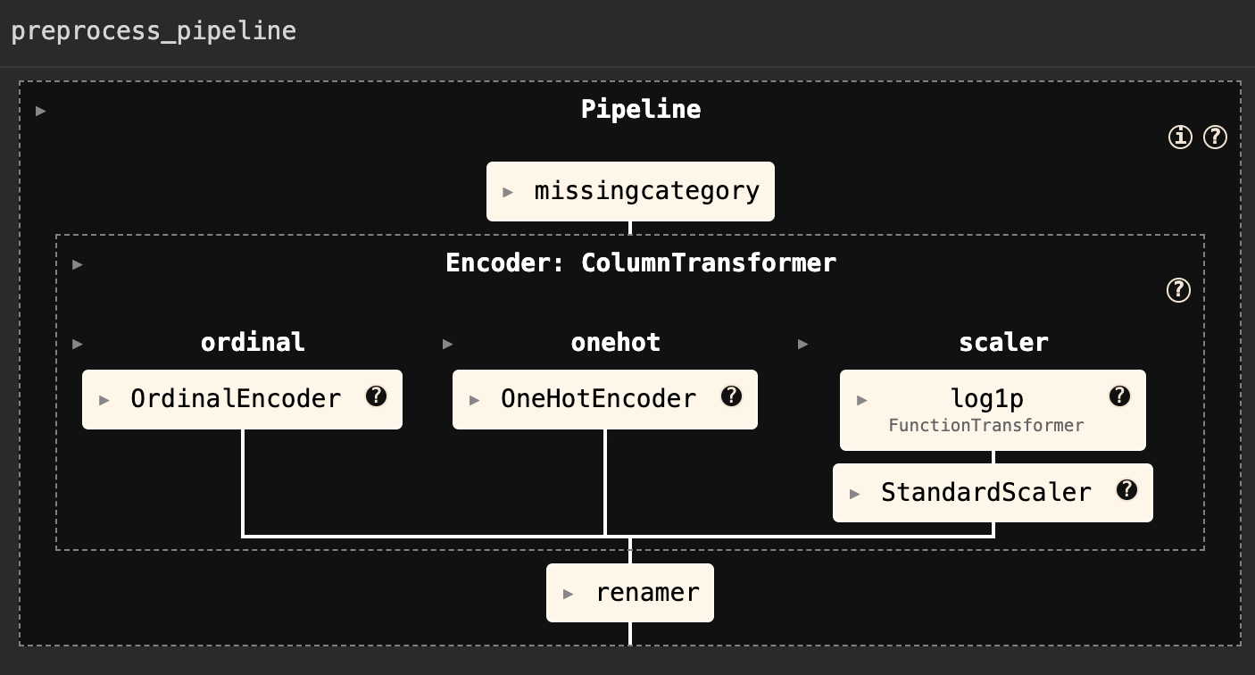

On the preprocessed data feature engineering was performed and it was observed that real estate credit can be removed based on the results but as no of Features are low we did not remove it. Later we can revisit these decisions after the feature importance from different tuned models and can make decisions if required.

Overfitting & Generalization.

Several models overfitting: Base Decision Tree, Random Forest, XGBoost, and HPT KNN all with gaps of 0.17–0.36. A very large train–test AUC gap signals overfitting.

Logistic Regression and SVM (both base and tuned) very small gaps (only ~0.05–0.09), indicating they did not overfit. The tuned Decision Tree also shows a tiny gap (0.03) but at the cost of dismal performance

Because the dataset’s positive class (risk/“bad credit”) is only ~30%, PR AUC is generally lower than ROC AUC for all models. This follows the well-known pattern that ROC AUC can be overly optimistic on imbalanced data.

For instance, HPT Random Forest has ROC AUC 0.789 but PR AUC only 0.638. In most models, PR AUC lags ROC AUC by a moderate margin (e.g. Base Logistic: ROC 0.668 vs PR 0.480).

Precision, Recall, and Class Imbalance.

No model simultaneously achieves high precision and high recall for the risk class. For example, HPT Random Forest has very high precision (0.78) but low recall (0.35). Conversely, HPT Logistic Regression has recall 0.617 (it catches most defaults) but low precision 0.42 (many false alarms).
Base XGBoost has a balanced profile (precision 0.571, recall 0.533) and thus highest F1 (0.552).
These trade-offs must be evaluated based on importance of project

Calibration and Error Metrics.(lower log-loss and Brier score)
HPT Random Forest has the lowest Brier score (0.166) and log-loss (0.506) - relatively well-calibrated probabilities (its probability estimates are closer to true frequencies).
In contrast, the Base Decision Tree is extremely uncalibrated: it has absurd log-loss (10.813) and Brier (0.300). Low calibration error means the model’s confidence matches reality: a model with Brier score 0 would be perfectly calibrated (always correct probabilistic forecasts).

Key Observations and Best Models.

Ensembles - Both Random Forest and XGBoost (base and tuned) achieved the highest test AUC (up to ~0.79).
Tuned RF (AUC 0.789) slightly outperforms base RF (0.759) and HPT XGBoost (0.761). This matches other studies: However, our base ensembles had train AUC =1.0, signaling overfit; tuning reduced that gap but sometimes at some cost to recall.

Support Vector Machine (SVM): Both base and tuned SVM yielded strong test AUC (~0.75) with relatively small overfit. Base SVM had the second-best precision (0.697) and decent accuracy (0.765). SVM’s calibrated outputs (log-loss ~0.520) are better than highly overfit models.

Logistic Regression: Both base and tuned logistic regression had the smallest AUC gap (0.05) but lower overall AUC (~0.67). Base logistic’s recall was very low (0.20), whereas tuned logistic achieved high recall (0.617). This can be due to Thresholds - Thresholds needs to be calibrated on basis of needs

Decision Trees: The base decision tree grossly overfits (AUC gap 0.36) and is outperformed by every ensemble. The tuned decision tree essentially collapsed to predicting all majority (accuracy 0.70), with zero recall (it never identifies a default).

K-Nearest Neighbors: Base KNN has moderate performance (test AUC 0.689) but somewhat overfits (gap 0.167). Tuning KNN eliminated training error (gap 0.262!) but did not improve test AUC much (0.737), reflecting an overfit choice of neighbors. Both KNN models have low recall (<0.30).

HPT Random Forest stands out for best ROC-AUC and precision, while Base XGBoost and Base SVM have strong balanced performance.

No model dominates all metrics, illustrating the precision–recall trade-off in imbalanced risk data. PR AUC values show how performance drops when focusing on the rare class: every model’s PR AUC is well below its ROC AUC, as expected on skewed data.

Conclusions and Recommendations:

First, any model showing perfect train performance but far weaker test results is overfitting and unreliable. Regularization or pruning (as in tuned RF/XGB/SVM) can reduce overfit, yielding better calibration and generalization. Further Action - Regularization and Pruning

Second, because defaults are the minority class, we should prioritize recall (catching defaults) if the cost of missing a defaulter is high. Models like HPT Logistic or Base XGBoost (balanced F1) might be preferred in that case over a high-precision/ low-recall model. Further Action - Scaling

Third, probability calibration (low Brier score) matters: the best models (tuned RF/SVM) also had lower log-loss/Brier, so their probability estimates can be trusted more for scoring. Further Action - Need to study how to improve Calibration

AUS Credit
Data Cleaning
There were no significant cleaning efforts made as the dataset was already good.

Data Preprocessing and Exploratory Observations
Imputation Status
The dataset was already pre-imputed at the source (Kaggle), and no additional imputation procedures were required. This allows the analysis to proceed directly to modeling without introducing imputation-induced variance.
Train-Test Split
The dataset was partitioned into training and testing subsets using an 80:20 split, with stratification on the target variable. This ensures preservation of class distribution across both subsets, which is essential for unbiased and reliable evaluation of classification models.
Feature Distribution and Transformation Strategy
Several numerical variables exhibit right-skewed distributions. While transformations such as logarithmic scaling may help normalize distributions and improve model performance, no transformation is applied at this stage.
Instead, a model-dependent approach is adopted:
Baseline models will first be trained on the original feature space.
Transformations will be introduced later to evaluate their marginal impact on performance, acknowledging that not all algorithms (e.g., tree-based models) benefit from such scaling.
Outlier Analysis
Outlier inspection indicates that most extreme values are concentrated in the age variable, with a maximum value of approximately 74.
These values are domain-valid and do not represent anomalies. In fact, higher age may carry predictive significance in a credit risk context. Therefore, no outlier removal is performed to avoid discarding potentially informative signals.
Multicollinearity Assessment
Both Variance Inflation Factor (VIF) and correlation matrix analysis indicate no significant multicollinearity among features. The feature set is thus considered stable for modeling, particularly for linear algorithms.
Feature Selection (Chi-Square Test)
Based on the Chi-square (χ²) test for independence, features A11 and A1 were identified as having low statistical association with the target variable.
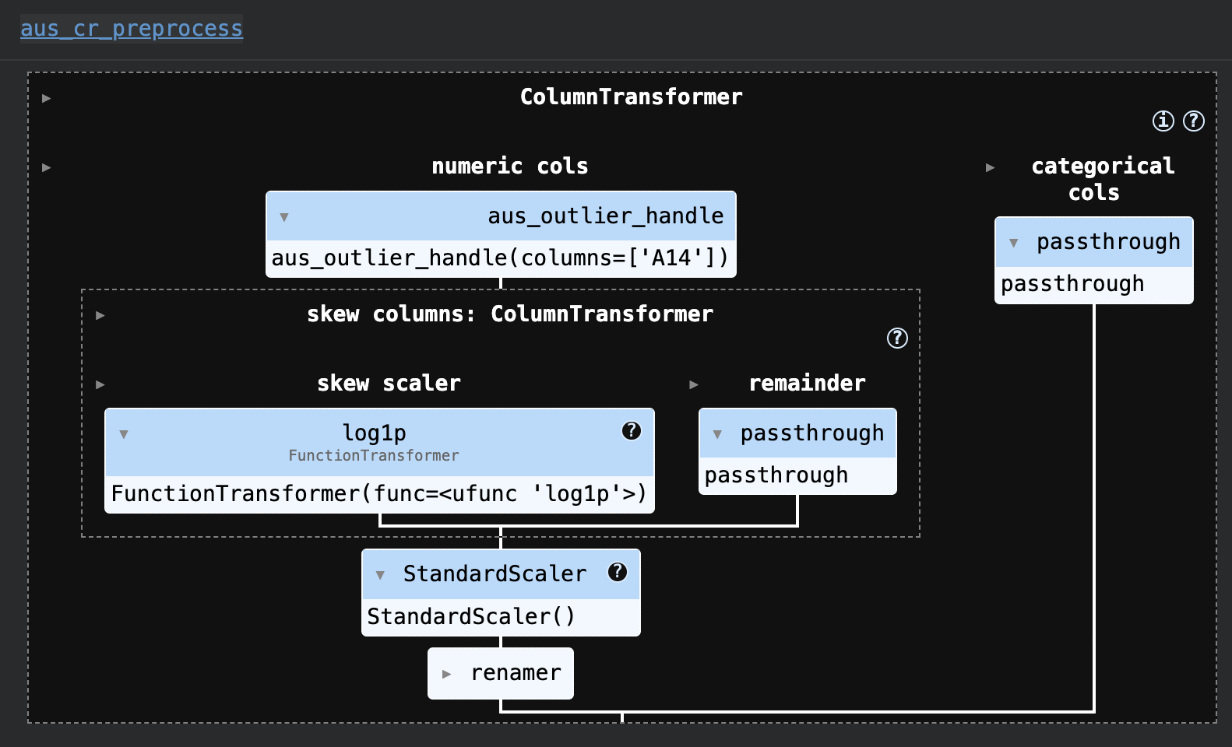

Model performance overview
We trained 12 models on the Aus_Credit.
All models achieve very high training AUC (above 0.93–1.00), but their test AUC and other metrics vary. For example, base XGBoost and Random Forest reach the highest test AUC (≈0.93 and 0.92, respectively), whereas K–Nearest Neighbors (KNN) and the unpruned Decision Tree have much lower test AUC (≈0.82 and 0.79). XGBoost achieves ≈0.86 accuracy, Random Forest ≈0.81, Logistic/SVM ≈0.81–0.82, while KNN is only ≈0.73 and the Decision Tree ≈0.79. In other words, XGBoost/RF are the top performers, while KNN and DT are the worst.

Training vs test gap:
Most models show some drop from training to test AUC, which signals overfitting. For instance, the base Decision Tree had train AUC=1.00 versus test AUC≈0.795 (a gap of ~0.205), and base KNN had a 0.939→0.817 drop (~0.123). These are large gaps, indicating overfitting. In contrast, Logistic Regression and SVM had very small AUC gaps (train≈0.94→test≈0.91, gap ~0.03), suggesting they generalized better.
Reason being while regularisation was used but after pruning was not performed.

Hyperparameter tuning effects:
The tuned models often improved on the base versions. For example, tuning dramatically raised the Decision Tree’s test AUC from 0.794→0.904 and improved KNN’s test AUC from 0.817→0.886. The tuned Random Forest and XGBoost also slightly improved (both ending near test AUC 0.92–0.94). However, tuning SVM actually reduced its test AUC (base SVM test AUC 0.914 → tuned 0.888). Overall, tuning reduced the train-test AUC gaps for most models (e.g. DT gap from 0.205→0.058, RF from 0.075→0.054, XGB from 0.068→0.045), meaning the tuned models generalized more stably.

Precision/recall/F1:
The classification reports (precision/recall by class) generally mirror accuracy and AUC findings. For example, base XGBoost (accuracy ~0.86) has high precision/recall in both classes, whereas base KNN (accuracy 0.73) has noticeably worse recall for at least one class. Macros (averages) of F1/recall are in the high 0.8’s for the best models and around 0.76–0.79 for the weaker ones. This again signals that XGBoost/RF give consistently better balanced performance, while KNN/DT miss more positives.

Calibration (Brier score):
We also measured Brier scores, which assess probabilistic calibration (lower is better). Tuned XGBoost achieved the lowest Brier (~0.072), followed by tuned Random Forest (~0.078), meaning their predicted probabilities are most accurate on average. Logistic and SVM have moderate Brier (~0.11–0.14). KNN (base) has the highest Brier (~0.268), indicating poor probability calibration. (A Brier score of 0 would be perfect; higher values mean worse prediction probabilities
.) Thus, XGBoost not only has high AUC but also better calibration than most others.

Conclusions:
Best models: Tuned XGBoost is overall the best performer (AUC ≈0.94, accuracy ≈0.87, lowest Brier). Tuned Random Forest is a close second (AUC ≈0.93, accuracy ≈0.86, Brier ≈0.08). These models achieved “outstanding” discrimination
. Logistic Regression and SVM (both base and tuned) performed reasonably (AUC ≈0.89–0.91, accuracy ≈0.81–0.82) and are good benchmarks.

Note: Logistic regression moderate performance is not something to be ignored keeping in mind the lower complexity, higher explainability, higher interpretability and lower cost

Poor performers: Base KNN and base Decision Tree are clearly inferior: they have the lowest test AUC (≈0.82 and 0.79) and largest train-test gaps (indicative of overfitting). Their accuracies (0.73 and 0.79) and F1 scores are also lowest, so they would not be recommended without significant tuning or regularization.

Although I would recommend not using knn for further study as the algorithm is slow and costly on large datasets and to compensate for that it does not offer any significant higher performance matrics
In case of DT the decisions can be explained via chart very clearly so the further efforts for tuning and pruning can be worth.

Effect of overfitting:
The large AUC/accuracy gaps in some models suggest overfitting. For example, base Decision Tree fitted the training data perfectly (AUC=1.0) but performed poorly on test (≈0.79) – a textbook sign of overfitting. In contrast, models like Logistic Regression and SVM, which have small train/test AUC differences, show better generalization
.

Hyperparameter tuning: Tuning helps reduce overfitting and often improves test AUC. The tuned tree-based models are much better than their defaults (e.g. tuned DT AUC +0.11 over base). An exception is SVM here, where tuning decreased test performance, possibly due to over-optimizing on the training folds.

Calibration and risk scores:
Since this is credit-risk prediction, calibrated probabilities matter. Models like XGBoost with low Brier score are preferable if we need reliable probability estimates for default risk. High Brier (as in KNN) indicates unreliable probabilities.

Overall performance:
All models except KNN/DT exceeded AUC 0.9 on training, and most had test AUC >0.85 (considered “excellent” to “outstanding”). This suggests the dataset is relatively easy to separate. However, any large train-test gaps should caution us – they mean the model learned some dataset-specific noise. It’s important to validate with cross-validation or a hold-out set (as done here).

Give Me Some Credit

Data Cleaning
Null values from “dependents” were removed directly as the number of rows were less. Reason being it is better to remove the null rows than impute it if the proportions are very less

Data Preprocessing and Exploratory Observations
Distribution Analysis
Examination of feature distributions did not reveal any immediately actionable patterns or anomalies that would necessitate direct intervention at this stage. However, it is observed that almost all numerical variables (except age) exhibit right-skewed distributions.

Data Quality and Preprocessing Requirements
The dataset appears structurally clean with no requirement for categorical encoding, indicating that variables are already in a model-consumable format.However, two key preprocessing challenges are identified:

Missing Value Analysis
Approximately ~20% of observations contain missing values, particularly in the MonthlyIncome feature.
The relationship between missingness and the target variable shows some variation in default rates, but not strong enough to conclusively treat missingness as purely random.
A notable structural relationship is observed between:
MonthlyIncome (missing values) and DebtRatio, suggesting a dependency (likely because MonthlyIncome is involved in the calculation of DebtRatio).

Key Consideration:
Standard imputation techniques such as KNN Imputation are not suitable in this context due to - Sensitivity to feature scaling, Presence of significant outliers, Risk of distorting underlying financial relationships

Adopted Approach: Introduce a missing indicator variable for MonthlyIncome Retain missing values instead of aggressively imputing. This approach preserves potential informational signals embedded in missingness, which is often valuable in credit risk modeling.

Outlier Analysis
Outliers are present across multiple features, particularly in:
DebtRatio
MonthlyIncome-related variables
The DebtRatio variable shows extreme values, raising concerns about its computation.
It is likely defined as a ratio involving MonthlyIncome as the denominator, which explains:
Amplified values when income is very low or missing. The observed linkage between missing income and extreme debt ratios In variables such as:
Number of Open Credit Lines
Real Estate Loans

higher values are associated with higher income segments, suggesting these are legitimate high-value observations rather than noise.

Conclusion on Outliers:

No blanket outlier removal is performed
Outliers are treated as potential signals rather than errors, especially in a financial risk context

Preprocess Pipeline:
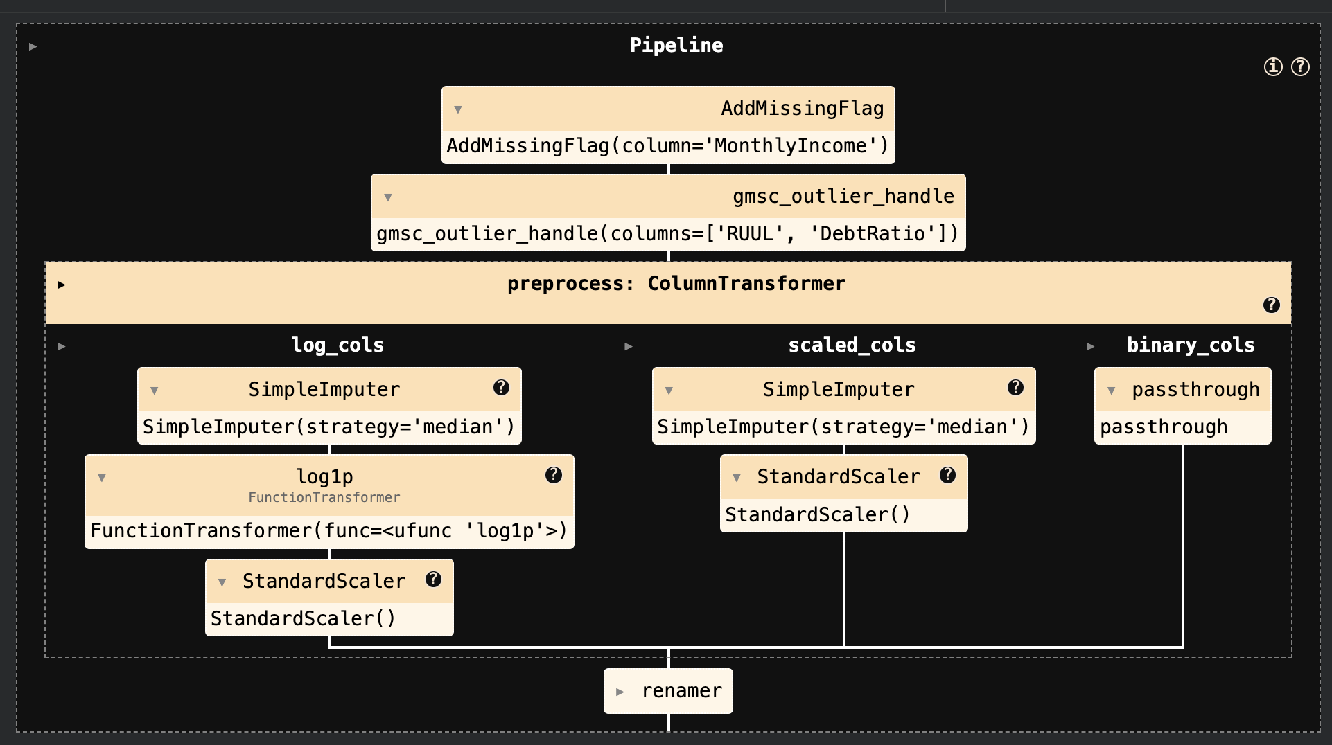

Model Performance on the GMSC Dataset

The GMSC credit dataset is highly imbalanced (≈93.3% non-defaults vs 6.7% defaults). Nine classifiers were evaluated (base and tuned versions of Logistic Regression, Decision Tree, Random Forest, XGBoost). All models achieved high overall accuracy (~0.94) simply by predicting the majority class, but AUC, precision /recall, and F1 reveal their true discriminative power. We compare train vs test AUC and other metrics to assess generalization and overfitting. (By convention, a higher AUC indicates a better model, but on imbalanced data precision/recall and F1 are also crucial.)

AUC and Overfitting: All models had good AUC on the test set (≈0.84–0.86) except the untuned Decision Tree (test AUC ≈0.61). The baseline Logistic Regression gave train AUC ≈0.849 and test AUC ≈0.844 (gap ≈0.005), indicating good generalization. The tuned Logistic (hyperparameter search) was similar (train 0.854, test 0.849, gap ≈0.005). In contrast, the base Decision Tree and Random Forest severely overfit: Decision Tree train AUC ≈1.000 vs test ≈0.610 (gap ≈0.39) and Random Forest train ≈0.999 vs test ≈0.830 (gap ≈0.17). XGBoost showed moderate overfitting (base XGB train ≈0.914, test ≈0.851, gap ≈0.063). Importantly, tuning mitigated this: the tuned Decision Tree had train AUC ≈0.859, test ≈0.848 (gap ≈0.010), and tuned XGBoost train ≈0.874, test ≈0.860 (gap ≈0.014). The best test AUC was ≈0.861 for the tuned Random Forest (train ≈0.893). Overall, models with a small train-test AUC gap (≲0.01–0.02) generalize better, whereas a large gap signals overfitting
.

Precision, Recall, F1: Because defaults are rare, accuracy is misleading. For example, the baseline Logistic Regression had very high class‑0 accuracy but poor default detection: its recall on class‑1 (defaults) was only ~0.17 and F1≈0.27 (precision ≈0.60). This means most defaults were missed. (In contrast, the model’s overall accuracy was 0.94). This trade-off is typical in imbalanced problems. Generally, all models had high precision but low recall for the minority class, yielding modest F1 for defaults. Tuned models improved recall slightly: e.g. the tuned Decision Tree and Random Forest raised recall by identifying more defaults (at the cost of more false positives). Nevertheless, no model achieved both high precision and high recall on defaults: the imbalance makes it hard to simultaneously catch many defaults (high recall) without many false alarms. We would ideally target a higher class‑1 recall (even if precision falls), since missing defaults is riskier than false positives in credit scoring.

Calibration / Brier Score: The training vs test calibration metrics (e.g. Brier score or log-loss) were generally similar, suggesting most models were fairly well-calibrated. For instance, Logistic Regression had train Brier ≈0.06293 vs test ≈0.06295 (difference negligible), and the tuned XGBoost likewise showed only a slight increase in test log-loss. A large train-test gap in log-loss for trees (e.g. base Decision Tree had near-zero train error vs test ≈0.1048) further indicates overfitting.

Conclusions:
The strongest models on the test set were the tuned ensemble models (Random Forest, XGBoost) with AUC ≈0.86. Hyperparameter tuning greatly reduced overfitting (see Decision Tree gap reduced from ~0.39 to ~0.01) and modestly improved AUC. By contrast, the simple Logistic Regression had lower absolute performance but was stable.
Key insights:
(1) A large train–test AUC gap flags overfitting
(2) accuracy alone is not informative here – focus on AUC and class‑1 F1/recall
(3) all models need further work on detecting defaults (e.g. oversampling or cost-sensitive tuning) because recall for class‑1 remains low.
CSC
Data Cleaning

The dataset contains longitudinal customer-level data spanning 8 months, where each customer_id is associated with 8 temporal records (one per month).
This introduces a panel (time-series cross-sectional) structure, rather than a purely independent tabular dataset.

A key implication is that repeated customer_id entries are not duplicates, but time-indexed observations. Therefore, cleaning required careful handling to preserve temporal consistency while eliminating true data quality issues.

Data Cleaning and Imputation
Basic Text Cleaning
Standard preprocessing steps were applied to ensure consistency in categorical/text fields (e.g., formatting, trimming, normalization).

Group-Based Imputation (Within Customer Consistency)
Given the panel structure, several features (e.g., Annual Income) are expected to remain constant across the 8-month period for a given customer. Therefore, missing values were imputed using group-wise aggregation (grouped by customer_id), ensuring:

Analysis of monthly trends indicates that most features do not exhibit significant variation across months.

Some numerical features exhibit right-skewed distributions, for which logarithmic transformations may improve normalization. However, no immediate transformation is applied, as: The effectiveness of such transformations is model-dependent. These were evaluated experimentally during model comparison.

Multicollinearity Assessment
Using Variance Inflation Factor (VIF) on the global dataset:
A subset of features (approximately 4 variables) shows high multicollinearity

Train-Test Splitting Strategy

Given the panel structure, a standard random split would lead to data leakage, as records from the same customer_id could appear in both training and testing sets.

To address this, Group-based splitting was implemented using: GroupShuffleSplit (from scikit-learn)

Preprocess Pipeline:
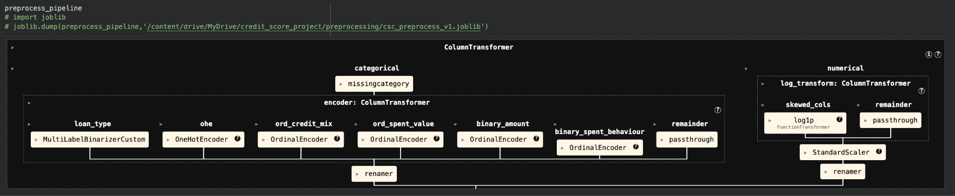

Model Performance and Generalization Analysis on the CSC Dataset
The CSC dataset is multi-class (three categories) and imbalanced (majority class ≈53%, minorities ≈29% and 18%). Overall, we see that models achieve moderate performance: test accuracy/F1 are around 0.64–0.65 (weighted) with higher performance on the dominant class and much lower recall on the minority class. Crucially, train–test gaps in metrics reveal overfitting versus generalization.

Train–Test Gaps and Overfitting:
The Base Decision Tree shows extreme overfitting (training AUC=1.00 vs test AUC≈0.672, a gap of ~0.328). Similarly, Base Random Forest has perfect training AUC (1.00) versus lower test AUC (~0.843, gap ~0.157), indicating it memorized training data. In contrast, tuned models greatly reduce this gap: for example, HPT Decision Tree has train AUC≈0.842 vs test AUC≈0.837 (gap ~0.005), nearly eliminating overfit. The two Logistic Regression models have very small AUC gaps (~0.002), showing both generalize well with no sign of overfit.

AUC-ROC Interpretation:

All models achieve AUC>>0.5 (random) on both sets. Base and tuned Logistic Regression have AUC≈0.79–0.80, the highest of all models, suggesting strong discriminative ability. HPT-tree (~0.84 train, 0.84 test) and HPT-ensembles (AUC≈0.85–0.89 train, ≈0.64–0.85 test) also perform well, though often slightly lower test-AUC than train. The classification reports show weighted average F1 ≈0.64–0.65, confirming this ranking (Logistic and tuned tree/XGB are on top).

Brier Scores (Calibration): The Brier score measures the mean squared error of predicted probabilities (lower is better; 0 is perfect). Base DT/RF have training Brier=0.00 (perfect on train) vs high test Brier (0.295–0.387), again indicating overfitting. Base/tuned Logistic and tuned tree/forest/XGB have consistent Brier ~0.27–0.35 on both sets, showing more calibrated, reliable probabilities and small train–test difference. For example, Base Logistic Brier_train=0.337 vs Brier_test=0.347 (gap ~0.002), essentially no calibration gap.
Precision, Recall and Class Imbalance
Due to class imbalance, accuracy alone is misleading. All models have overall accuracy ≈0.65, but this masks poorer performance on minority classes. Indeed, in the test reports, Class 1 (majority) achieves high recall (≈0.81) while Class 2 (minority) has very low recall (≈0.40–0.55). For example, Base Logistic had Class2 recall ≈0.40 (vs Class1=0.81). Precision and recall must be examined per class and in aggregate. As recommended, we consider F1 score (harmonic mean of precision and recall) for imbalanced data. All models yield weighted F1 ≈0.64–0.65, but class-wise F1 is much lower for the small class.

Logistic models (base & tuned): Both show similar multi-class precision/recall patterns, with ~0.65–0.72 precision, ~0.40–0.81 recall across classes. The slight hyperparameter tuning did not greatly alter behavior.

Decision trees: Base DT overfits, leading to artificially perfect training classification and poor test recall on smaller classes (test recall on class2 still low). Tuned DT trades off some train fit for better balance (moderate precision/recall across classes).

Ensembles (RF, XGB): These have higher precision on Class 1 (up to ~0.75–0.79) but lower recall on Class 0/2 (recall often <0.55). Hyperparameter tuning (HPT) slightly boosts the minority-class recall at the cost of some majority-class precision, producing more balanced F1.
Consistently, models struggle on the smallest class: low recall (many false negatives) suggests the model often misses that class.

Overfitting vs Underfitting and Model Comparison

Overfitting:
Base Decision Tree is the clearest case: near-perfect train metrics but far worse test metrics (large gaps in AUC, accuracy, Brier), a textbook sign of overfitting. Base Random Forest also overfits heavily (train AUC=1, test=AUC<0.85). The large train–test performance gap is analogous to Model C in the Azure example (99.9% vs 45% accuracy) indicating clear overfit. Base XGBoost shows a moderate gap (train AUC ~0.946 vs test ~0.843).

Generalization: Both Logistic models and the tuned Decision Tree/RF/XGB have very small train-test gaps. For example, Base/HPT-Logistic and HPT-Tree have ∼0.002–0.005 AUC difference; their test accuracy is only marginally below training accuracy. This matches Model A/B scenarios (small gap is acceptable). The tuned models generalized well, often at slightly lower absolute performance than the overfit versions but with more reliable test results.

Underfitting: No model shows classic underfitting (low performance on both train and test). The HPT Decision Tree actually reduced complexity and so its train AUC fell from 1.0 to ~0.84, yet its test AUC remained ~0.84 – this is not underfitting but successful regularization (removing overfit). The HPT Logistic had similar train/test AUC to base, so also not underfitting.

Conclusions and Recommendations
Best models: The highest AUC and balanced performance come from Logistic Regression and tuned tree-based models. Base/Tuned Logistic regressions have the highest AUC (~0.80) with excellent generalization (virtually no gap), suggesting robust performance. Tuned XGBoost and Random Forest also do well (test AUC ≈0.84–0.85) with minimal overfitting.

Conclusion

Logistic Regression: This industry‐standard model yielded moderate predictive accuracy on our credit datasets. Logistic regression tended to have relatively low Brier scores (good calibration) and small overfitting gaps (train/test AUC differed by only ~0.05–0.06). However, its overall AUC/precision was generally surpassed by modern classifiers. In line with credit‐scoring literature, we used logistic regression as a baseline; it remains highly interpretable and reliable, but our results suggest it is outperformed by more flexible methods in raw accuracy.

Decision Tree: A single CART decision tree gave the weakest results of all models. Its AUC was lowest across most datasets (German ≈0.36, Aus ≈0.21) and it was extremely unstable. For example, the tree fit the training data perfectly (AUC=1.0) but collapsed on test data (AUC drop of 0.64 on German Credit). Even after hyperparameter tuning (smaller tree depth), performance only improved modestly (German AUC up to ≈0.71). In short, decision trees suffered from severe overfitting and low generalization. They showed the worst accuracy and recall on minority classes and do not provide competitive PD estimates without ensembling.

K-Nearest Neighbors: The KNN model achieved middling accuracy. On the binary datasets it consistently beat the simple decision tree but lagged behind logistic regression and ensembles. For instance, KNN attained test AUC ≈0.69 (German) and ≈0.82 (Aus), versus logistic’s 0.67 and 0.91 on the same sets. KNN showed moderate overfitting (e.g. train AUC≈0.94 vs test≈0.82 on Aus), reflecting sensitivity to data size and class balance. Its F1/precision results were average (≈0.81 on German, ≈0.73 on Aus), indicating reasonable but not outstanding predictive power. In summary, KNN captured nonlinearity in the data somewhat better than a single tree but could not match the structured models

Random Forest: The random forest (RF) ensemble was among the best performers in our study. It achieved the highest or near-highest AUC on nearly every dataset (German ≈0.76, Aus ≈0.92, CSC ≈0.84, GMSC ≈0.83 on test). These AUCs significantly surpassed those of logistic regression and other individuals in most cases. RF also yielded very strong accuracy and F1, and competitive Brier scores (e.g. German Brier ≈0.17, Aus ≈0.11), reflecting both high discrimination and good calibration. Overfitting was present (train AUC=1.0 on small sets) but was mitigated by using many trees and default regularization; test AUC gaps were moderate. Overall, RF’s performance confirms the consensus that tree-based ensembles are powerful for credit PD estimation. In our analysis, RF required minimal tuning yet delivered consistently accurate PD predictions.

Support Vector Machine (SVM): The SVM (RBF kernel) behaved similarly to logistic regression in terms of accuracy. It produced high AUC on the Aus set (≈0.91, almost matching RF) and decent AUC on German (≈0.75), but never clearly exceeded the random forest or boosting models. SVM’s F1 scores were mid-high (≈0.74 weighted on German). Like logistic, SVM’s overfitting gap was small (train vs test AUC differed by ≈0.08 on German), reflecting stable estimation. In short, SVM provided competitive results among linear classifiers and captured some nonlinearity, but did not offer a substantial leap over logistic for these credit risk tasks. Its advantage might be in certain feature spaces, but it was not the dominant model in our comparisons.

XGBoost (Gradient Boosting): The XGBoost model was another top performer. On our binary datasets it achieved AUC nearly matching or slightly exceeding RF (German ≈0.75, Aus ≈0.93 test AUC). On the large multi-class CSC data, it also outperformed logistic (AUC≈0.85 vs logistic’s ≈0.79). With tuning, XGBoost reached the highest AUC of any model on Aus (≈0.935) and CSC (≈0.851), reflecting its ability to fit complex patterns. Its precision/recall and F1 were also strong. Like RF, XGBoost did show overfitting on small sets (train AUC=1.0 vs test≈0.76 on German) but this was controlled via cross-validation. Overall, gradient boosting delivered very accurate PD estimates across datasets. Its complexity means it requires careful tuning and less interpretability than logistic, but in this study it matched or slightly outperformed the random forest.

Overall: Advanced ensemble methods gave the best predictive performance, echoing findings in the literature. Homogeneous ensembles (Random Forest, XGBoost) dominated the individual learners (logistic, tree, KNN, SVM), with RF typically ranking at or near the top. Logistic regression, while a useful standard (and strong on calibration/Brier), was outdone in AUC by these ensembles on most tasks. No single “new” technique (e.g. complex neural nets) was evaluated here, but our results suggest that established methods like RF and boosting continue to excel. Practitioners should therefore use RF/XGBoost as benchmarks when developing new scorecards. At the same time, model choice involves trade-offs: logistic models offer transparency and regulatory acceptance, whereas boosted trees deliver higher accuracy at the cost of complexity. In conclusion, our multi-dataset comparison indicates that, for retail credit scoring, ensemble techniques provide the most accurate default predictions, whereas simpler classifiers serve as useful baselines for performance and interpretability.

Comparison with Study ( Benchmarking state-of-the-art classification algorithms for credit scoring: A ten-year update )

Our results largely agree with the cited literature. Both find that homogeneous ensemble classifiers (like RF/boosting) dominate individual models. In both studies, neural networks were cited as strong, but our study did not include NNs; however, we do not contradict the claim that NN can surpass logistic regression. The prior paper noted that ensembles (including a greedy “HCES-Bag”) outperformed RF. We similarly find no single model beats RF, reinforcing the idea that progress is incremental. On metrics, the literature observed that AUC (discrimination) and Brier (calibration) can disagree; we also saw that ranking by AUC and by Brier produces a slightly different ordering.

Key similarities: Both our study and the reference emphasize that RF should be the reference benchmark, and that logistic regression is simply the industry baseline, not a gold standard. We found that, like them, logistic regression performs “medium” on average but often yields good calibration (as reflected in its relatively low Brier score).

Differences: The cited work used 7 credit datasets and 41 classifiers (including cutting-edge ensembles and neural nets), whereas our study covered 4 datasets and 12 model variants. They observed that a complex ensemble (HCES-Bag) was the best, whereas we did not implement that method. Also, they analyzed additional metrics (PCC, H-measure) and discussed rule extraction and regulatory aspects; our focus was narrower on AUC, Brier, etc. Finally, they questioned the practical business value of tiny accuracy gains.

Key takeaways & Learnings

1. Feature Selection is Not Optional — It is Foundational
One of the strongest learnings from this project is the critical importance of feature selection.
- Techniques like Chi-Square, ANOVA, Correlation Analysis, and VIF were not just exploratory tools but decision-making instruments
- Removing multicollinearity significantly improved model stability and interpretability
- Feature selection directly influenced:
  - Model generalization
  - Overfitting behavior
  - Training efficiency

2. Data Cleaning & Preprocessing Drive Model Performance
A major realization was that model performance is heavily dependent on preprocessing quality.
- Handling missing values using contextual/group-based imputation proved superior to generic methods
- Outlier handling required domain understanding, not just statistical thresholds
- Transformations like log scaling for skewed variables had a measurable impact on model performance

3. Class Imbalance is a Central Challenge in Credit Risk
Across datasets like GMSC, severe imbalance led to:
- High accuracy but poor recall for minority (default) class
- Models like Logistic Regression showed:
  - Good probability calibration
  - But poor sensitivity toward defaulters
This highlighted:
- The need to evaluate beyond accuracy
- Importance of Precision-Recall tradeoff and PR-AUC
- Necessity of techniques like:
  - Class weighting
  - Threshold tuning

4. Model Development is an Iterative, Multi-Directional Process
A key insight:
There is no linear path from data → model → result
Instead, the process involved continuous loops between:
- Feature engineering
- Model selection
- Hyperparameter tuning
- Evaluation
For example:
- Improving preprocessing changed feature distributions → impacted model assumptions → required re-tuning
- Tuning models exposed overfitting → required revisiting feature selection
This reinforces that ML development is a feedback-driven system, not a pipeline in the strict sense

5. Pipelines and Modular Design are Essential for Scalability
Building reusable preprocessing pipelines and custom transformers provided:
- Reproducibility across datasets
- Cleaner experimentation
- Reduced chances of data leakage
- Production-level thinking in workflow design
The creation of a custom module for transformers introduced:
- Encapsulation of logic
- Better maintainability
- Alignment with real-world ML system design
However, it also highlighted that:
- Production systems vary significantly across organizations
- There is still more to learn in deployment architecture and orchestration

6. Understanding Model Internals is Crucial
Evaluation is not just about metrics—it requires understanding model behavior:
- Decision Trees → prone to overfitting (observed via high ROC gap)
- Random Forest → reduced variance but still struggled with minority recall
- Logistic Regression → stable and well-calibrated but limited in capturing non-linearity
- XGBoost → strong performance but sensitive to hyperparameters

7. Evaluation Metrics Must Align with Business Objective
A critical learning was the importance of metric selection:
- Accuracy alone was misleading in imbalanced datasets
- ROC-AUC provided ranking quality
- PR-AUC provided minority class sensitivity insight
- KS Statistic helped measure separation power (important in credit scoring)
- LogLoss and Brier Score evaluated probability calibration

8. Overfitting and Generalization Must Be Explicitly Monitored
Using metrics like:
- ROC train vs test difference
- Train/Test error gap
- Tree-based models often showed significant overfitting gaps
- Linear models showed low variance but higher bias
This highlights:
- The bias-variance tradeoff is not theoretical—it is directly observable in real datasets

9. Hyperparameter Tuning is Powerful but Context-Dependent
Using:
- GridSearchCV
- Random Search
- Optuna
- Tuning improves performance but does not compensate for poor data quality
- Over-tuning can lead to:
  - Overfitting
  - Reduced generalization
Thus:
Tuning refines a good model—it does not fix a bad one

10. No Universal Best Model Across Datasets
Across the four datasets:
- Some models performed well on one dataset but poorly on others
- Dataset characteristics (size, imbalance, feature types) significantly impacted performance
This aligns with research literature:
There is no “silver bullet” model in credit risk modeling

11. Ensemble Models Show Strong Performance but Not Always Dominant
- Random Forest and XGBoost generally performed better than single models
- However:
  - Gains were sometimes marginal
  - Interpretability decreased
This leads to a practical trade-off:
- Accuracy vs Interpretability
- Important in regulated domains like finance

12. Decision-Making in ML is Contextual and Interdependent
Every decision depends on multiple factors and cannot be made in isolation
Examples:
- Choosing imputation depends on feature distribution
- Choosing model depends on data size and imbalance
- Choosing metric depends on business risk

13. Transition from Academic Learning to Applied Thinking
This project marked a shift from:
- Learning algorithms → understanding systems
- Running models → designing workflows
- Comparing metrics → interpreting outcomes

Limitations & Future Scope

1. Limited Interpretability & Explainability Analysis
While multiple models were trained and evaluated, model interpretability was not explored in depth.

Limitation:
- No use of explainability techniques such as:
  - SHAP (Shapley Additive Explanations)
  - LIME
  - Feature importance decomposition beyond basic methods
- Lack of insight into:
  - Feature-level contribution to predictions
  - Local vs global interpretability

Future Scope:
- Perform model explainability analysis, especially for:
  - Tree-based ensembles (Random Forest, XGBoost)
- Compare interpretability vs performance trade-offs
- Important for regulatory compliance (e.g., credit decision transparency)

2. Handling of Class Imbalance Can Be Improved
Although class imbalance was identified as a major issue, advanced resampling techniques were not applied.

Limitation:
- Heavy imbalance (especially in GMSC dataset) led to:
  - Poor recall for minority (default) class
  - Misleading high accuracy

Future Scope:
- Apply resampling techniques:
  - SMOTE / SMOTE-NC
  - ADASYN
  - Undersampling strategies
- Explore:
  - Cost-sensitive learning
  - Threshold optimization
- Evaluate impact on:
  - Recall
  - PR-AUC
  - Business risk (false negatives)

3. Hyperparameter Optimization Objective was Narrow
Hyperparameter tuning was primarily driven by ROC-AUC.

Limitation:
- ROC-AUC does not fully capture:
  - Class imbalance sensitivity
  - Business-specific misclassification costs
- Models optimized for ROC-AUC may not perform best in:
  - Recall
  - Precision
  - Calibration

Future Scope:
- Use multi-objective optimization, including:
  - PR-AUC
  - F1-score
  - KS Statistic
  - Brier Score
- Explore custom scoring functions aligned with credit risk objectives

4. Calibration Analysis was Limited
Although calibration metrics (LogLoss, Brier Score) were computed, calibration was not deeply analyzed or improved.

Limitation:
- No calibration plots (reliability curves) were generated
- No calibration techniques applied:
  - Platt Scaling
  - Isotonic Regression

Future Scope:
- Perform probability calibration analysis
- Improve probability estimates for:
  - Better risk ranking
  - More reliable PD (Probability of Default) estimation
- Particularly important for:
  - Financial decision systems
  - Risk-based pricing

5. Overfitting Control Can Be Further Strengthened
Overfitting was identified using ROC gaps and train-test differences, but systematic mitigation strategies were limited.

Limitation:
- Some models (especially tree-based) showed:
  - High variance
  - Large train-test performance gaps

Future Scope:
- Introduce:
  - Cross-validation (k-fold, stratified)
  - Regularization techniques
  - Early stopping (for boosting models)
- Study bias-variance tradeoff more rigorously

6. Limited Model Coverage
The study included several classical and ensemble models, but did not explore deep learning approaches.

Limitation:
- No Neural Networks or advanced architectures tested
- No comparison with:
  - Deep learning-based tabular models
  - Hybrid or stacking ensembles

Future Scope:
- Explore:
  - Artificial Neural Networks (ANNs)
  - Deep learning models for tabular data (e.g., TabNet)
- Investigate:
  - Ensemble stacking/blending approaches
- Benchmark against:
  - Existing strong models (e.g., Random Forest, XGBoost)

7. Dataset Diversity Can Be Expanded
Although four datasets were used, broader dataset diversity could improve generalizability.

Limitation:
- Limited exposure to:
  - Different geographies
  - Different credit products
  - Time-series credit behavior

Future Scope:
- Include:
  - More real-world datasets
  - Temporal datasets (loan lifecycle data)
- Perform:
  - Cross-dataset generalization study

8. Lack of Business-Oriented Evaluation Framework
The evaluation was technically strong but not explicitly mapped to business outcomes.

Limitation:
- No cost-sensitive evaluation:
  - False positives vs false negatives impact not quantified
- No simulation of:
  - Credit approval strategies
  - Profit/loss scenarios

Future Scope:
- Introduce:
  - Cost matrices
  - Expected loss / profit modeling
- Align model evaluation with:
  - Lending decisions
  - Risk appetite

9. Pipeline Productionization & Deployment Not Covered
While pipelines were built, deployment and real-world integration were not explored.

Limitation:
- No work on:
  - Model deployment (APIs, batch scoring)
  - Monitoring and drift detection
  - CI/CD for ML pipelines

Future Scope:
- Extend project toward:
  - MLOps practices
  - Model monitoring
  - Data drift and performance tracking
- Explore tools like:
  - Docker, Airflow, MLflow

